LAB :

Reddy Dorniya  
192372061

**How to create a clone in GitHub step by step:**

**Step 1**: Go to github and create a repository

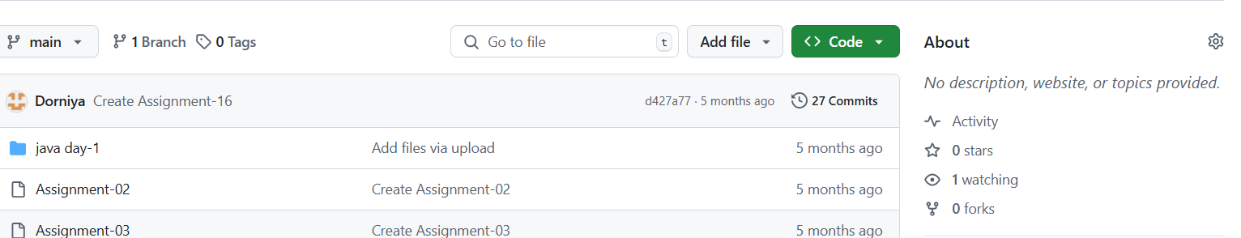

**Step2: Click the code option**

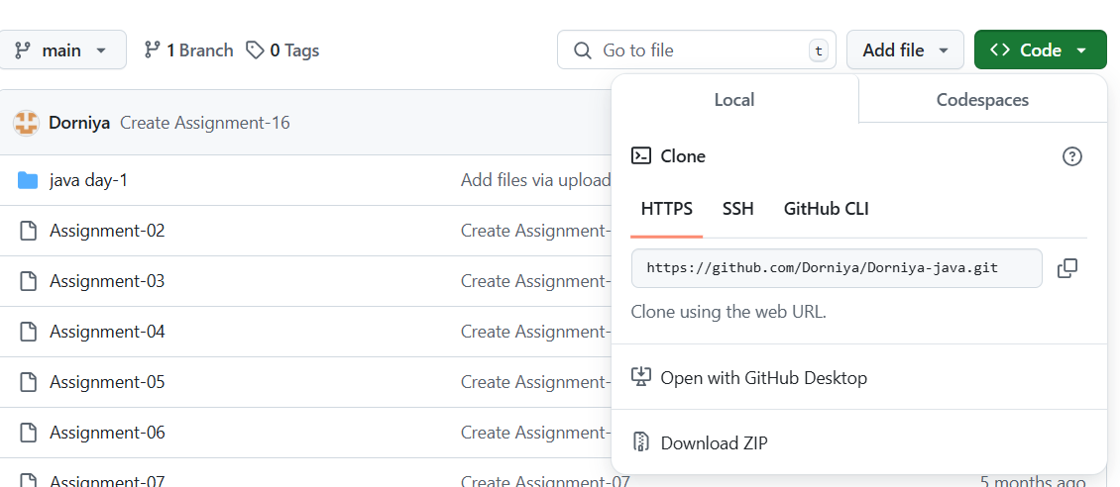

**Step3: Copy the clone url**

**1.if you click the code it will show the options like https,SSH,Github**

**2.Copy the URL of https**

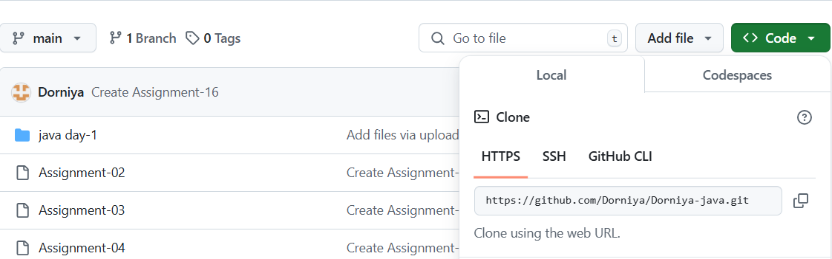

**Step 4: Open your files**

1. **Open your files and create a new folder called sample**
2. **Download a Gitbash app**

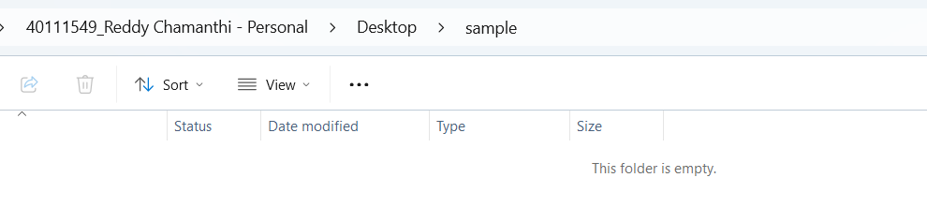

**Step 5: Click on the sample 2**

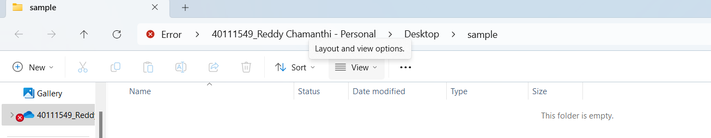

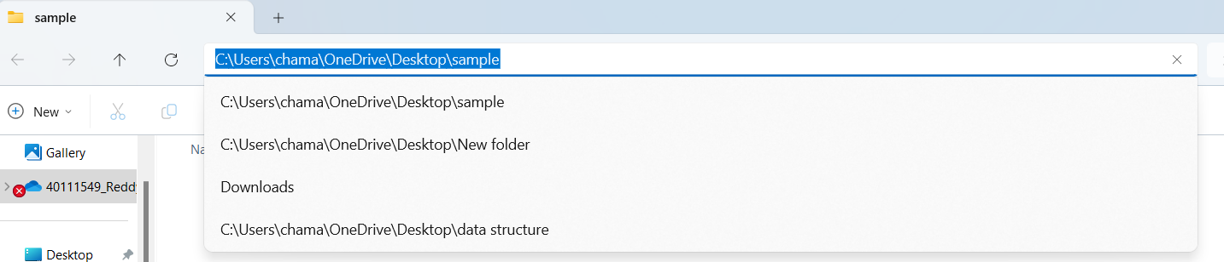

**Step 6: Copy the C:\sample 2 and open the gitbash**

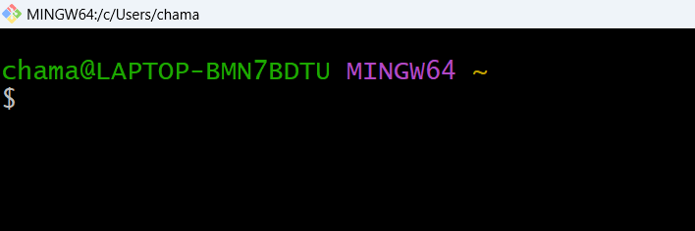

**Step 7: Type cd and paste the sample 2 code “C:\sample 2” and press enter**

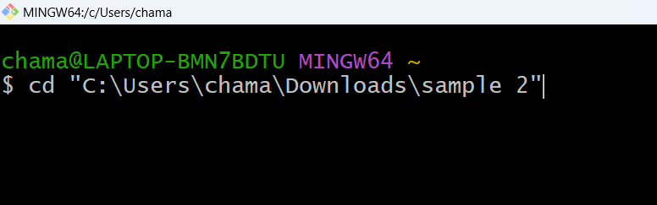

**Step 8: Type git clone and paste the https code and press enter**

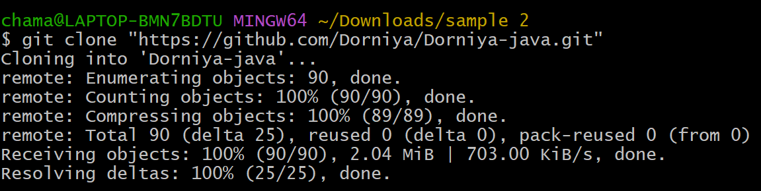

**Step 9: Type ls**



**Step 10: Go the files and press sample 2**

